Kick-off project partner meeting
25th of January, 2023
"Lauku celotajs" office, Kalnciema Street 40, 3rd floor, Rīga, Latvia

The next project partner / SG meeting is scheduled to take place on 9th/10th of May.
A smaller project partner online meeting is scheduled to take place on 21st of March, 10:00.
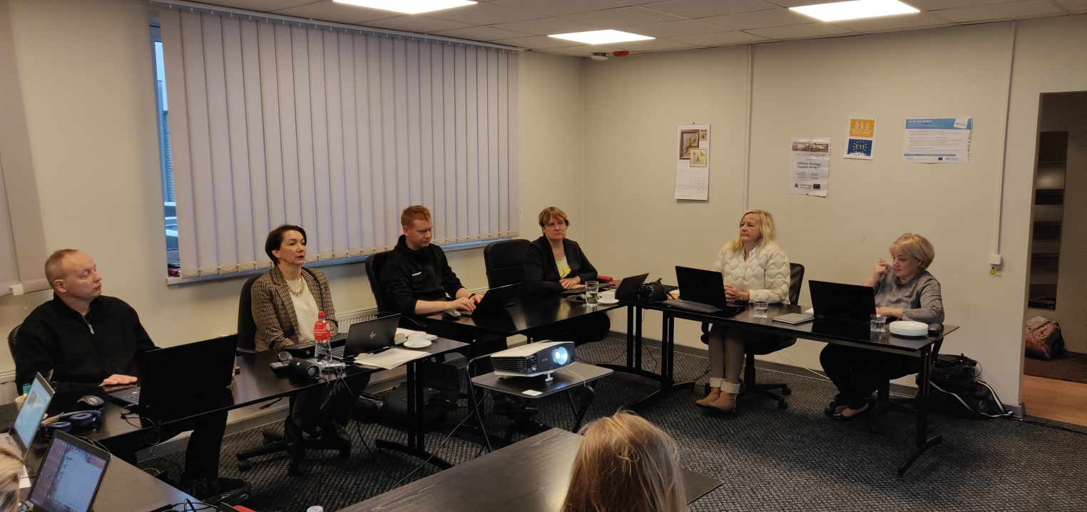
Introduction of the agenda.
Emphasis on the main project outputs. Output discussion, 50+100 SMEs.
Basic criteria should be created for SMEs to qualify for the output 50 SMEs / to sell to the UK.
For example, cooperation with nature tourism guides. Is the product website in English? It may be difficult to find nature guides that are good experts and also speak good English. Criteria should be developed in a month time. Google drive document will be created and shared with partners.
A reminder that each company cannot have a direct benefit of more than 20 000 euros from the project.
Management and steering groups:
The project Management group will consist of Asnate Ziemele, Raili Mengel, Matijs Babris and Marilin Pehka.
The project Steering group – LV tourism board, potentially Ieva Gredzena? EE tourism board? Tour operator association? Someone who could help with sales and marketing.
Next meetings:
Next project partner meeting will be held in Estonia with 2 steering group members participating. 5 SMEs from Latvia must be present. The first day would be the project meeting and the second day would be the study tour. The places of visit for the study tour should be interesting for the specific SMEs taken. May, June? Lump sums for all meetings.
Dates – 9th of may project meeting, 10th of May study tour.
If enough funds are available in travel budgets, it is possible to take more SMEsto the meetings/study tours, for example, Estonians can also participate in meetings held in Estonia.
Estonian partners should have the agenda ready a month before the event.

A smaller project partner online meeting (Zoom platform) is scheduled to take place on 21st of March, 10:00.

Activity 1.1, Matching the nature and tourist service potential with the UK market needs:
A table with nature tourism types and short descriptions of them.
https://docs.google.com/document/d/1Vegate9ha5KRwRGsBeOHg6_MIOtK1te1L8-B5ThRG9g/edit
Should fishing be included? Is it possible to sell it?
Another table with specific companies will be made. A survey must be prepared for the SMEs. The survey should include the criteria selections.
Deadline for 1.1. delivery – 15.03., deadline for 1.2. delivery – end of March.
Project implementation principles,
Samu Numminen, Project Manager at Central Baltic Programme 2021 – 2027:
Info about the subsidy contract, programme manual, guide for project reporting, communication guide and the partnership agreement.
The partnership agreement should be made.
Main focus on results, output and result indicators should be achieved.
Lead partner principle. The LP has the overall responsibility, ensures the timely and correct implementation of the project.
Project modofications.
1) Minor changes - Modifications having no impact to the Subsidy Contract.
2) Modifications having impact to the Subsidy Contract. Max 2 times and no later than six months before the project end.
Flexibility rule - Maximum 20% or 40 000 euro flexibility (whichever is higher)of the individual cost category on project level allowed.
There will be some kind of feedback system for events organized.
Excel sheets for working hours will be sent to us.
Price comparison is obligatory from 10 000 EUR.
Project web space instead of a separate project website.
Information poster (min. A3) informing about the project and the received EU funding in partner organization premises. LP will send out an example.
Lead partner seminar about communication and project implementation will be held sometime in May, face-to-face.
Project implementation for seminar all partners will be held sometime in autumn, on-line.
Activity 1.2, Training support to SMES for product development and improvement:
How would the price survey and agreement look? It is difficult to precisely define the task. Agreement sample from Lea?
Activity 1.3, Best practice study trip for SMES - nature tourism product providers:
1 study tour to Finland or Sweden. Anneli could give more info about the possibilities in Finland.
A google drive document should be created where ideas for destinations could be gathered. Sites + descriptions.
Activity 1.4, Nature tourism product development:
It is necessary to help create the sales product for those SMEs that will not have it 100% ready.

Activity 1.5, Visual identity and web design for presentation of the nature tourism product:
The LP designer will create some design samples, which will be then discussed and chosen.
If anyone has some ideas please share them. All ideas can be discussed in the 21st or March meeting.
Activity 1.6, Estonian-Latvian nature tourism product promo materials:

A satellite map should be included in the product brochure.

Activity 1.7, National dissemination events:
Activity 1.8, Nature tourism web platform:
Discussions about the fact that the "buy" button should be as visible and accessible as possible.
How to track booking numbers if there are different platforms? Do SMEs themselves report the numbers? Booking engines that already in use for nature tourism products?
Guidelines for booking options, sample products?
Legal aspects from selling products through our web platform?
Activity 1.9, Project communication to SME target audience:
Project summary must be included in each project partners website. Must be reported in the 1st RP.
LC example - https://www.celotajs.lv/en/project/36.
Activity 2.1, Estonian-Latvian nature tourism product presentation at specialised travel trade events:
The events don't have to be in the UK, they can be anywhere, as long as the product is presented also to British people and in English.
Activity 2.2, FAM trips for UK tour operators, travel companies and media:
Activity 2.3, Estonian-Latvian nature tourism product presentation at travel markets:
Do we decide for ourselves or leave it to the contracted British experts?
Activity 2.4, Estonian-Latvian nature tourism product presentation to nature organisations in the UK:
Activity 2.5, Sales calls to specialised companies in UK:
Activity 2.6, Digital marketing:
Facebook account should be made.
Activity 2.7, E-newsletters and press releases:
Activity 2.8, Review of other sales and marketing platforms:
Activity 2.9, Project communication to general public:
Partners need to register in JEMS and send their e-mails to the LP so we can add them under the project.
A table with SMEs, where tourism type categories are chosen. Is the product already being sold to the UK? What improvements would they want, what topics would they like to learn? What could help to increase the sales?
2-3 lines of introduction for the survey. Survey should be in English. Survey until of mid-February.
What will the domain be for the web platform? Should be included in the promo material for NORDIC MARKETPLACE 2023 B2B workshop. The promo material could be a ~10x15cm postcard.
What should the domain name be?
Balticnature.eu?
Balticnaturetourism.com
Balticnature.com for (2500eur asking price)?
Balticnature.travel?

