Press release 02.06.2022.
Put on your hiking boots and get ready for the Baltic Trails!
Fully completed – with marking signs, maps, guidebooks and specialised website – the Baltic Trails are there offering marvellous nature experiences to hikers in Estonia, Latvia and Lithuania.

The Baltic Coastal Hiking Route and the Forest Trail are two long distance hiking trails in the Baltic States. Jointly referred to as the Baltic Trails, they open Estonia, Latvia, and Lithuania for the world’s hiking community, and are linked with the European network of long-distance hiking paths. Trail developers have put great effort in exploring the trail in full length, involving local communities to set the best route and prepare for visitors, marking and signposting the trails, producing guidebooks and maps. Hiking in the Baltic States means enjoying great nature diversity and true local hospitality.

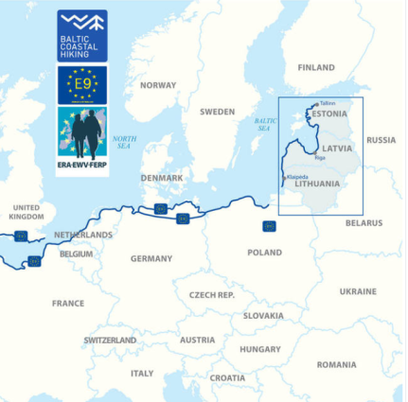
The Baltic Coastal Hiking Route follows the Baltic Sea coastline. It starts at the Russian-Lithuanian border, goes through Lithuania and Latvia and finishes in Tallinn, Estonia.
The route length is 1419 km, including 216 km in Lithuania, 581 km in Latvia and 622 km in Estonia.
This trail is part of the European long distance hiking path E9 starting in Portugal and ending in Tallinn. The E9 route crosses 10 countries: Portugal, Spain, France, Belgium, the Netherlands, Germany, Poland, Lithuania, Latvia and Estonia.

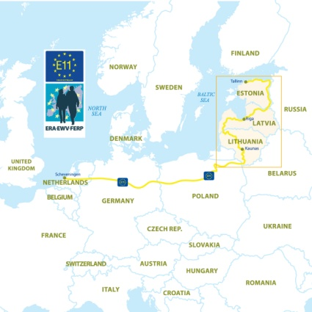
The Forest Trail leads through the most beautiful forests and national parks in Lithuania, Latvia and Estonia. The starting point of the Forest trail is on the Polish-Lithuanian border, then it crosses Lithuania and Latvia, and the end point is Tallinn, Estonia.
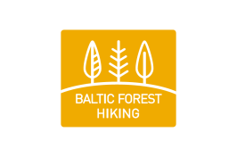
The route length is 2141 km, including 747 km in Lithuania, 674 km in Latvia and 720 km in Estonia.
The Forest Trail is a part of the European e-path E11 passing through six countries — the Netherlands, Germany, Poland, Lithuania, Latvia and Estonia.

The Baltic trails visit 9 national parks, 1 biosphere reserve, and more than 100 protected nature areas offering stunning nature sights and wildlife. Both trails visit UNESCO world heritage sites - Old Town Riga (LV) and Old Town Tallinn (EE). On the Baltic Coastal Hiking Route there is another UNESCO world heritage site - the Curonian Spit, a unique, sandy and wooded cultural landscape featuring small Curonian lagoon settlements. The Forest Trail also visits Kaunas (LT), approved by UNESCO as a City of Design.
It would take approximately 2 ½ months to walk the Baltic Coastal Hiking Route and 3 ½ months to walk the Forest Trail in full length.
Both trails are divided in approximately 20km long daytime sections with overnight accommodation and food options, and hikers can pick any section for a short holiday hike or plan a long distance trip. Altogether there are around 2000 service providers on both trails.
How to plan your hiking trip:
- On-line information
Hikers will find full and detailed information at baltictrails.eu web site such as descriptions of the route sections with start and end points, trail surface, sites worth seeing on the way. There is more information about the most interesting and significant places, landscapes, natural values, places to eat, buy water and snacks, and also spend the night. Maps and downloadable GPX routes are also on the web site as well as inspiring videos from the trails. The Baltic Trails can be explored in any season of a year.
- Downloadable guidebooks and maps
There is a set of guidebooks and maps hikers can download and use on a trip where on-line service might not be available. Find all information – how to get there, where to stay, where to eat and buy food, what to see on the way.
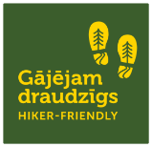
The “Hiker-Friendly” label marks those tourist services in Estonia, Latvia and Lithuania where hikers are welcome, their needs are understood and respected. These companies offer specialized services for hikers, for example: information about the route, drinking water, first-aid kit, charging electronic devices, facilities to wash, clean and dry clothing, footwear and other hiking gear. The label works under the same criteria in all three countries.
Guidebooks and maps for the Baltic Coastal Hiking
Guidebooks and maps for the Forest Trail

Forest Trail Southern part opening hikes in Latvia and Lithuania
The Forest Trail is divided into the Southern and the Northern part. The Southern part starts from the Polish/Lithuanian border (Lazdijai), and goes through Lithuania and the Latvian region of Kurzeme to Riga. With the Southern part as the final stage in the trail development process, the Forest Trail is now fully completed – with marking signs along the whole route, maps, guidebooks and specialised website.
Two paralel hiking events marked the official opening of the Forest Trail presenting the most attractive and scenic parts of the Forest Trail in Lithuania and Latvia:
- In Lithuania the opening hike on May 21 crossed one of the most beautiful section of the Forest Trail in the country, the route meandering between the largest lakes in the Samogitian National Park: Paplatelė – Plateliai.
- In Latvia, on May 22 over a hundred enthuiastic hikers experienced the route Snēpele- Kuldīga enjoying the spring scenery in the countryside and the charming Kuldīga town as a final destination.

Get inspired and feel the hiking spirit of the Baltic Trails watching the videos from the Baltic Coastal Hiking and from the Forest Trail . Follow us on Facebook to be a part of the enthusiastic hikers’ community and learn stories form other hikers.
See you on the trail!
Latvia: facebook.com/meztaka
Lithiania: https://www.facebook.com/baltictrailsltmiskotakasjurutakas
Estonia: https://www.facebook.com/metsamatkarada
instagram.com/meztaka
instagram.com/baltictrailslt
instagram.com/metsamatkarada
@Forest Trail

Project LLI-448 “Development of Forest trail in Latvia and Lithuania and expanding the Baltic Coastal Hiking route in Lithuania” (Hiking project) is being implemented with the support of the European Union Interreg V-A Latvia–Lithuania Cross Border Cooperation Programme 2014–2020. Total costs of the project are EUR 788,104. Co-funding by the European Regional Development Fund is EUR 669,888.
This publication has been produced with the financial assistance of the European Union. The contents of this publication are the sole responsibility of Latvian country tourism association „Lauku ceļotājs” and can under no circumstances be regarded as reflecting the position of the European Union.

