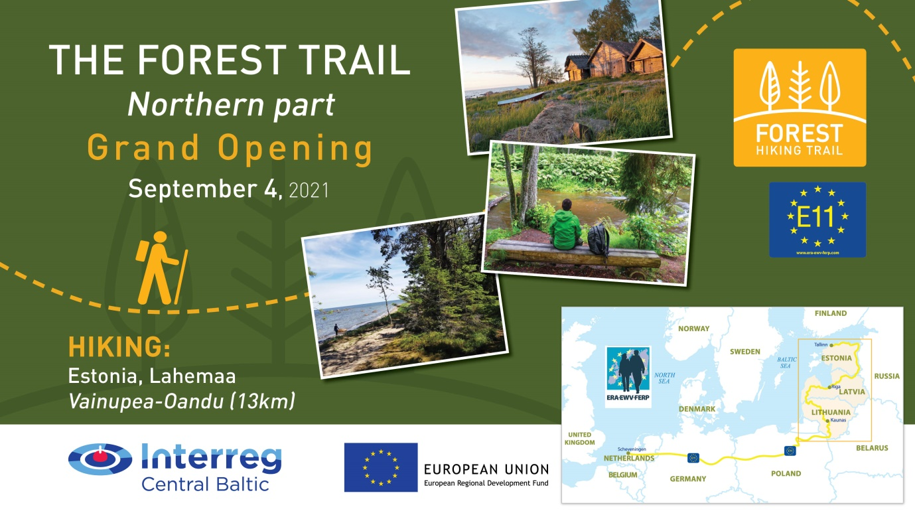
Press release 09.08.2021.
Hiking festival on September 4 in Lahemaa – the Grand Opening of the Forest Trail as part of the E11 long distance hiking path in the Baltic States
With a hiking tour on September 4 in Lahemaa national park, Estonia the Forest Trail will be launched as part of E11 long distance hiking path of the European hiking path network. Everybody is welcome to join the 13km opening hike from Vainupea to Oandu villages in Lahemaa national park.
Tallinn in Estonia is the final destination in the E11 long distance hiking path of the European hiking path network. The E11 route goes: Scheveningen (NL)–Osnabrück (D)–Potsdam (D)–Poznań (PL)–Ogrodniki (PL)–Lazdijai (LIT)–Rīga (LAT)–Tallinn (EST).
The Forest Trail in the Baltic States leads through the most forested lands, regional, nature and national parks of Lithuania, Latvia and Estonia. The route starts from the Polish - Lithuanian border near the town of Lazdijai, leads through Latvia, turning into Riga, and finishes in Tallinn, Estonia. The route is divided into ~ 20 km long one-day or two-day sections with accommodation and transport options.
The opening hike on September 4 will start with the registered participants gathering at Oandu village, the final destination point. They will park their cars there and will be taken by bus to the starting point at Vainupea village. Before starting the hike, the Forest Trail will be officially launched as part of E11 by a representative from ERA - European Ramblers association addressing the hikers.
The 13 km hike from Vainupea to Oandu will start at 12:00. The participants will take a lunch break at Mustoja Campfire Site. Further the route leads through Altja historical seaside village, with coastal farms, fishing net sheds, and the tavern.
The hike will end in the afternoon, arriving to Oandu village at around 16:00. The event will close with greetings, thanking, eating, and concert of a local youth folk band “Uurikad”.
Event programme: https://galerija.celotajs.lv/g/www/news/2021/Forest_trail_0409.pdf
Registration: https://forms.gle/ziL6FG1N9tSgrgRb7
(Only those who have a valid Covid-19 certificate can attend the hike.)
The Forest Trail welcomes everybody to go for a hike any time, with a guidebook and map in hand following the marking signs and signposts. Route GPX files for each section are downloadable from https://baltictrails.eu/en/forest. The website content is mobile friendly. Forest Trail info is also available from many hiking apps https://baltictrails.eu/lv/forest/apps. It is advised to make printouts that will be useful in areas with poor mobile network coverage.
Please let us know if you would like to attend to this and we will send you more information.
- Katrina Serzante
Baltic country holidays / THE FOREST TRAIL project
katrina@celotajs.lv
- Kaisa Linno
Contact person for THE HIKING FESTIVAL
kaisa@kolgakyla.ee

See you on the Forest Trail!
Sincerely yours,
Latvian country tourism association ‘’Lauku ceļotājs”” and the Forest Trail team
Follow us:
- baltictrails.eu
- facebook.com/meztaka
- instagram.com/meztaka

The Forest Trail's Northern part (from Riga-Tallinn) is being currently developed under the Central Baltic program project No. 779 'Long distance cross border hiking trail 'The Forest Trail''.
This provided information reflects the views of the author. The managing authority of the programme is not liable for how this information may be used.

