Press release November, 2021
Two long distance hiking trails now link Lithuania, Latvia and Estonia with rest of Europe
The three Baltic countries are now linked with the European network of long distance hiking paths prolonging the routes E9 and E11.

The Baltic Coastal Hiking Route and the Forest Trail are two long distance hiking trails in the Baltic States. Jointly referred to as the Baltic Trails, they open Latvia, Lithuania and Estonia for the world’s hiking community.

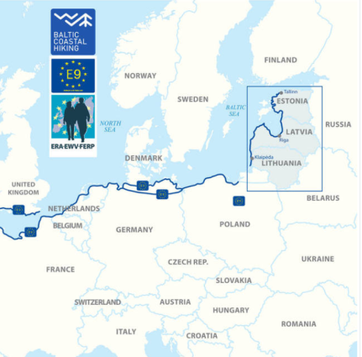
The Baltic Coastal Hiking Route follows the Baltic Sea coastline. It starts at the Russian-Lithuanian border, goes through Lithuania and Latvia and finishes in Tallinn, Estonia.
The route length is 1419 km, including 216 km in Lithuania, 581 km in Latvia and 622 km in Estonia.
This trail is part of the European long distance hiking path E9 starting in Portugal and ending in Tallinn. The E9 route crosses 10 countries: Portugal, Spain, France, Belgium, the Netherlands, Germany, Poland, Lithuania, Latvia and Estonia.

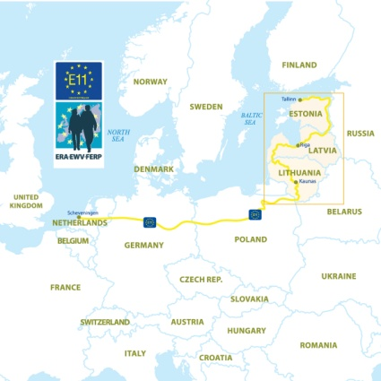
The Forest Trail leads through the most beautiful forests and national parks in Lithuania, Latvia and Estonia. The starting point of the Forest trail is on the Polish-Lithuanian border, then it crosses Lithuania and Latvia, and the end point is Tallinn, Estonia.
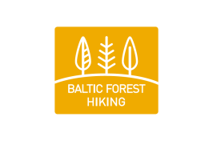
The route length is 2141 km, including 747 km in Lithuania, 674 km in Latvia and 720 km in Estonia.
The Forest Trail is a part of the European e-path E11 passing through six countries — the Netherlands, Germany, Poland, Lithuania, Latvia and Estonia.

The Baltic trails visit 9 national parks, 1 biosphere reserve, and more than 100 protected nature areas offering stunning nature sights and wildlife. Both trails visit UNESCO world heritage sites - Old Town Riga (LV) and Old Town Tallinn (EE). On the Baltic Coastal Hiking Route there is another UNESCO world heritage site - the Curonian Spit, a unique, sandy and wooded cultural landscape featuring small Curonian lagoon settlements. The Forest Trail also visits Kaunas (LT), approved by UNESCO as a City of Design.
It would take approximately 2 ½ months to walk the Baltic Coastal Hiking Route and 3 ½ months to walk the Forest Trail in full length. Both trails are divided in approximately 20km long daytime sections with overnight accommodation and food options, and hikers can pick any section for a short holiday hike or plan a long distance trip. Altogether there are around 2000 service providers on both trails.
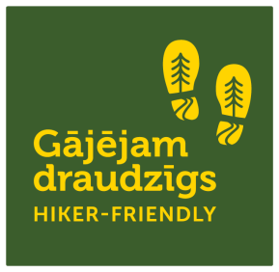
The “Hiker-Friendly” label marks those tourist services in Latvia, Lithuania and Estonia where hikers are welcome, their needs are understood and respected. These companies offer specialized services for hikers, for example: information about the route, drinking water, first-aid kit, charging electronic devices, facilities to wash, clean and dry clothing, footwear and other hiking gear. The label works under the same criteria in all three countries.

Hikers will find full and detailed information at baltictrails.eu web site such as descriptions of the route sections with start and end points, trail surface, sites worth seeing on the way. There is more information about the most interesting and significant places, landscapes, natural values, places to eat, buy water and snacks, and also spend the night. Maps and downloadable GPX routes are also on the web site as well as inspiring videos from the trails. The Baltic Trails can be explored in any season of a year.

The project “The long-distance cross-border hiking route FOREST TRAIL” (04/01/2019 - 06/30/2021) is partly funded by the European Union and the Central Baltic Programme 2014-2020 of the European Regional Development Fund.
Project LLI-448 “Development of Forest trail in Latvia and Lithuania and expanding the Baltic Coastal Hiking route in Lithuania” (Hiking project) is being implemented with the support of the European Union Interreg V-A Latvia–Lithuania Cross Border Cooperation Programme 2014–2020. Total costs of the project are EUR 788,104. Co-funding by the European Regional Development Fund is EUR 669,888.
This publication has been produced with the financial assistance of the European Union. The contents of this publication are the sole responsibility of Latvian country tourism association „Lauku ceļotājs” and can under no circumstances be regarded as reflecting the position of the European Union.

