News for the media 29 June 2018

**Countryside of Baltic States and Finland attracts Japanese Tourism Market**

[**http://balticsea.countryholidays.info/**](http://balticsea.countryholidays.info/)

Several marketing events are implemented this year with the purpose of raising the interest of Japanese tourists about the region of Estonia, Latvia and southern Finland and providing more practical information on travel opportunities.   
New marketing publications for Japanese market have been released and the representatives of Latvian, Estonian and Finnish tourism sector are participating in several marketing events in Japan. A group of Japanese journalists are arriving to Latvia and Estonia this weekend. They will enjoy the atmosphere of the Song Festival procession, visit the countryside and experience special sensations at Barefoot trail of *Valguma Pasaule*, visit a real rural homestead Dzirnupes, as well as the fruit garden and home wine production facility of *Zilveru vīni.* After the visit to Latvia, the group of journalist will continue their way to Estonia and Finland.

**New manual of rural tourism products *Go rural 2018***

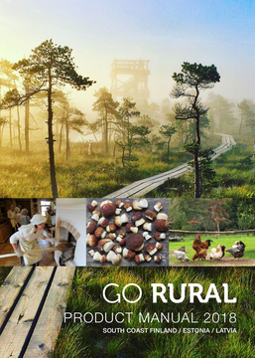We have prepared a manual of rural tourism products *Go rural 2018*. This is the second edition, updated and supplemented, based on the experience of the activities and results of last year’s marketing events. As tourism businesses and tour operators have observed, Japanese tourists like not only traditional tourist destinations of Latvia, but also the offers associated with environment and plant world, for instance, nature trails, picking mushrooms, learning about local medicinal herbs, etc.

The manual is intended for tour operators, professionals of the sector and travellers. It has been published and printed in Japanese, as well as its electronic version is available in English. The manual includes practical information that helps while planning your trip - programmes of single day excursions in the countryside, visits to producing farmhouses and craftsmen’s workshops, homesteads, which introduce to the traditional rural lifestyle, visits to rural hotels and SPA facilities, as well as multiple-day-long tourism programmes. In response to the interest of tour operators and Japanese travellers, the offers of wedding trips are also included in the manual. The manual contains information on public transport, as well as the contact information of Latvian, Estonian and Finnish tour operators.

Electronic version: http://caitoproject.eu/category/news/

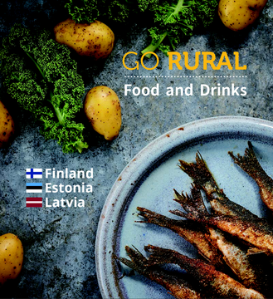**Brochure *GoRural Food and Drinks***

The publication introduces the reader with typical Finnish, Estonian and Latvian meals that are both traditional and contemporary and can be found on the menus of cafeterias and restaurants. The cuisine of our countries has lots in common in terms of food recipes, as well as the ways of product use. Fresh, seasonal local products are highly valued, however, each country has their own meals and traditions of cooking and serving them. The *GoRural Food and Drinks* brochure is meant to encourage Japanese visitors to learn about our traditional meals and food habits. Each description of a dish included in the brochure contains the list of ingredients used in its preparation, the way of cooking and a photo. The descriptions have been grouped in chapters: Cheese, Greens and Salads, Soups, Fish Dishes, Meat Dishes, Mushrooms, Bread, Sweet Dishes, Pancakes, Drinks.

The brochure has been compiled in English as well, but it has been printed in Japanese. Electronic version: http://caitoproject.eu/category/news/

***Baltic Road Show* events**

A series of presentation events will be held in several largest cities of Japan (Osaka, Nagoya, Tokyo) in July, where the professionals of the Baltic tourism sector will introduce the representatives of Japanese tourism sector (~150 professionals) with the Baltic states as a common tourism destination and jointly developed offer of rural tourism with traditional tourism destinations, as well as the possibility of group and individual travel. This event is organised by tourism organisations of 3 Baltic States and we are participating in it with our offer of rural tourism opportunities. The objective of the event is to invite the representatives of Japanese tour operators and media to participate in the introductory visit and to encourage them to include the Baltic States on their travel programmes. Meeting permits better understanding of the wishes and needs of the Japanese tourism market, and to prepare answers to questions. The visitors of the *Road Show* events shall receive both aforementioned marketing publications, as well as small gifts made by our craftsmen and home food producers.

The marketing expenses have been covered and events have been prepared by uniting in a single project the effort of rural tourism associations of Latvia and Estonia and the regional tourism bureau of the Southern Finland, as well as several universities, as well as in co-operation with Investment and Development Agency of Latvia (LIAA) and Estonian and Finnish Tourist Board.

